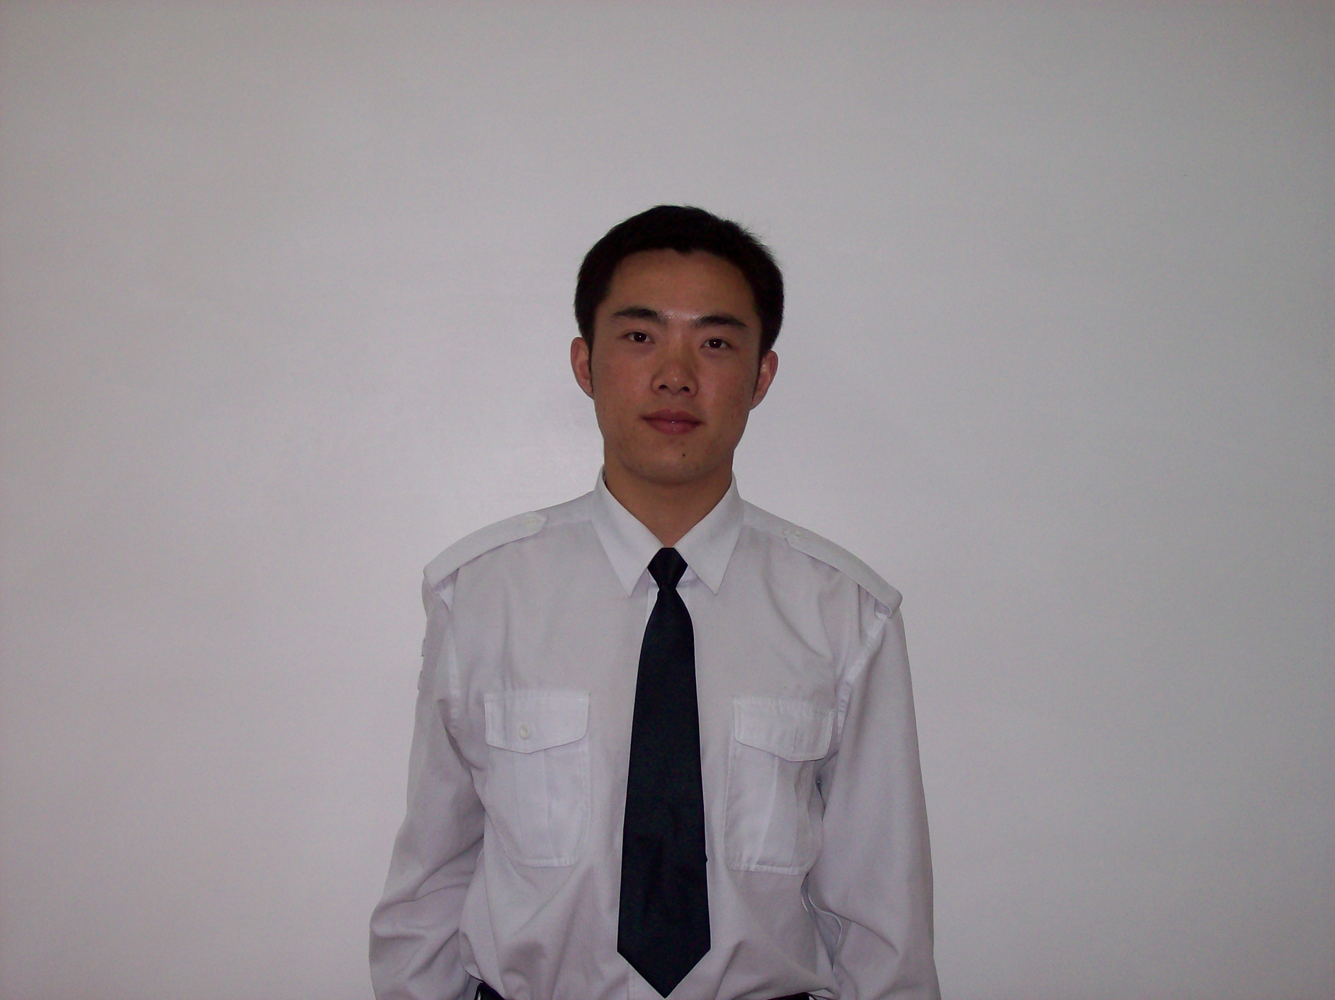
Yi CHEN, postgraduate student, majors in the theory and technique of chart, the generation technique of navigable area.

REAL-TIME VISUALIZATION MODEL AND TECHNIQUE OF NAVIGABLE AREA BASED ON DIGITAL NAUTICAL CHART
Y. Chen, R. C. Peng, G. H. Liu, W. J. Gao
Dept. of Hydrography and Cartography, Dalian Naval Academy, Dalian, China, 116018
Telephone: +86-411-85856431
Fax: +86-411-85856431
E-mail: cychangzhou1983@126.com
Abstract: Since the late 90s of last century, GIS has being applied to more and more fields. With the development of the technique, more and more people pay attention to the factor of time, i.e. the new temporal-GIS system should be able to analyze spatio-temporal factors in the real world. This paper presents a research project suggesting the use of spatio-temporal techniques as navigation aid onboard ships. Firstly, constructing the model of real-time soundings, dynamic depth contours drawing and area constructing and so on. Secondly, analyze the parameter of the ship. At last, present the navigable area based on a digital nautical chart with regards to navigational information (such as the tide, the real-time soundings, the ocean current and so on) and the parameter of the ship. The main objective is to meet the special needs of navy, such as emergency operation and salvage and to lessen the cognitive load of the bridge personal.

Keywords: GIS, Temporal GIS, Navigable Area, Navigation, Data Structure
- Introduction
In recent years, more and more people pay attention to oceanic problems and a lot of new conception systems and research techniques are constructed and developed, i.e. 3D digital chart, marine optical technique and so on. Some experts propose to build ocean TGIS for the construction of the digital earth. However, the current research and the development condition show that, the related conception system, the model calculating way and application path etc. are still on theories research stage. Under this background, the paper talks about building a navigation supporting system based on real-time visualization of navigable area with regard to tide, which carries out the ocean TGIS in the concrete application in navigation.
- Related Work
In recent years, many papers have discussed the problems of using a land-based GIS for marine applications. Probably one of the first articles about Marine GIS is the one by Davis (1988), in which they state that variables in three dimensions, plus time and attributes are needed to correctly represent the marine phenomena. Li and Saxena (1993), Lockwood and Li (1995) and Wright and Goodchild (1997) give a complete review of what sets apart a Marine GIS from a land-based GIS; they state that objects at sea are different from objects on the ground because they are likely to change position over time, they have three-dimensional coordinates, they are mostly represented by points (lines and polygons are scarce at sea) and the distribution of samples is usually ‘abnormal’ (data are sparse in one or two dimensions but abundant in the others). If the nature of the data is completely different, why should a land-based GIS be used for marine applications? The major problems of traditional GIS are that their spatial model is built for static two-dimensional land applications and their data structure is based on the ‘overlays’ as a definition of adjacencies between objects. The only thing that has been done, by commercial companies, to solve these problems is trying to extend – by adding new kinds of analysis and by modifying the database model – the spatial data model of current GIS; but the real problems are the spatial model used and the building of the topology process, not the database aspect (Gold, 1991). A Marine GIS needs a dynamic data structure to handle time and objects moving over time.
- General of the Problem
The sea surface moves all the time, which courses the depth changing. While the land usually stays still, so it’s obvious that, the data structures, visualization model and algorithms of the land-based GIS are not appropriate for marine applications.
One of the most obvious problems for the voyager at sea is the danger of underwater shoals. The remedy for this problem has been to make soundings of the water and present depth as figures in the nautical chart. However, even in modern day charts the sheer amount of soundings can cause cognitive strain. The problem with the presentation of depth data is that every number has to be read before one can make a decision whether a ship will have enough water under the keel or not. An improvement to this problem is called chart generalization. Soundings are classified into depth intervals connected with isobars called depth curves. Standard curves are, for example, 3, 6 and 10 meters. A generalized chart is much easier to read. Although the generalized chart is a lot easier to read, there will still be some mental calculations to be done if a sudden evasive maneuver is forcing a ship off its planned route. Draft, tidal level and wave amplitude has to be compared to the sounding figures. A dynamic display is instead suggested, taking the above parameters into account and presenting the navigator with a chart showing the most important area: the navigable area.
Here comes the conception of navigable area. The problem about the navigable area is always the most important one concerned by the voyager. However, in the voyage activity of the earlier period, people did not know what exactly the navigable area is, their understanding about it was misty and rough, and they did not treat it as a science concept, make accurate calculation and showing of the navigable area, they just mark off the navigable area by their experiences roughly, and this situation even lasts till now.
Science the 80's of last century, the electronic navigational chart (ENC for short) has being used in navigation, which brings a huge progress for the voyage technique. However, the ENC could not analyze and show the navigable area accurately and dynamically. It follows the traditional way used on the paper chart, i.e. selects a deeper isobaths based on the sea gauge of the ship as the safe ones, and then makes the navigable area roughly. It’s obviously that, without the consideration of the tide and rigor compute of the safe isobaths based on the sea gauge of the ship, the navigable area is only a static one for the ship, and it is reduced for the sake of safe.
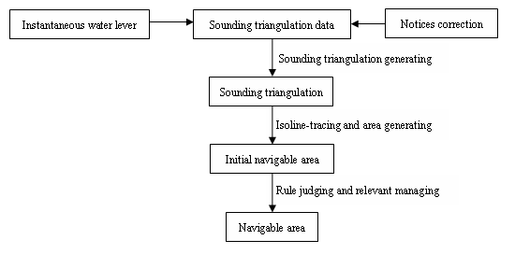

Fig. 1. The main steps of navigable area generation.
- Theoretical Background
  - Conceptions
- Navigable Area
As to the aspect of application, the navigable area should be a dynamical conception, which may change along with the time. So, we set a new conception for the navigable area, that is in a period of time, the conditions related to navigation such as the depth, the width, the ocean current, the weather and so on are all fit for navigating of a special kind of ship, however, the area may change along with the time.
- Basic Soundings
Because the research is based on the electronic nautical chart, we call the soundings marked on the chart the basic soundings.
- Instantaneous Water Lever
During the course of sounding, the influence of tide has to be eliminated for the sake of steady submarine topography. So the instantaneous depth will be corrected to steady depth datum, and this correct is called the correct of water lever. The soundings been corrected would be marked on the nautical chart (basic soundings). And the instantaneous water lever means correct the basic soundings with regard to tide, get back to the instantaneous sea lever. It’s the contrary course of the correct of water lever.
- Dynamic Triangulation Network
The triangulation network of the instantaneous soundings is called the dynamic triangulation network.
- Tide-coordinated Safe Line
The instantaneous water lever moves along with the tide, while the sea gauge of the ship is immovable. The depth contours constructed by the instantaneous soundings with regard to the sea gauge of the ship is called the tide-coordinated safe line.
  - Mathematical Models of Spatial Data
    - Instantaneous Water Lever Model
For the sake of expressing the sea lever’s dynamical change, the instantaneous soundings have to be ascertained. The model 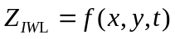 (IWL means the instantaneous water lever) is used to show the instantaneous sea lever. Theoretically, the exact calculation of 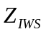 has to take the hydrodynamic simulation and the change of the sea lever shape into account. In this paper, we use a method called the horizontal method to express the instantaneous sea lever, because this method is practicable, convenient and accord with the fact. In this model, the model 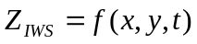 could be predigested to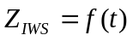, i.e. the water lever changes along with the time and is independent of the position. The equation is as follows:
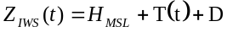 (1)
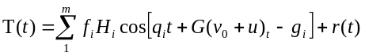 (2)
In this equation, 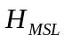 means the mean sea lever from the depth datum, means the number of the tide, 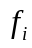is the gene of the intersecting point, 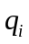 is the velocity of the tide, 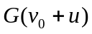 is the Greenwich astronomical phase, 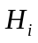 is the swing of the tide, g is the special angle of the tide, 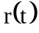 is the surplus water lever, all of these parameters could be gained by the tidal observation.
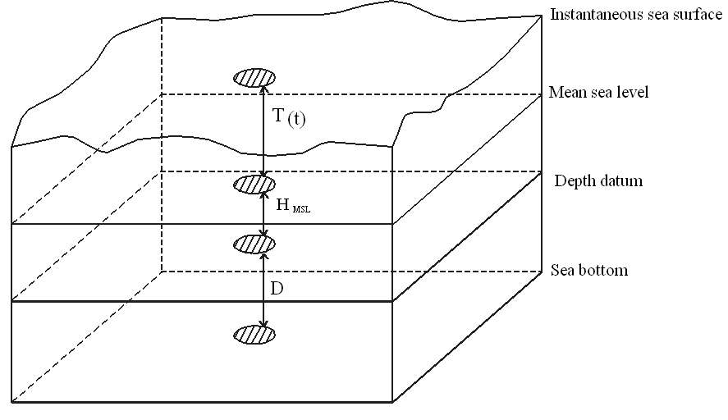

Fig. 2. The spatial field structure of sea sounding
    - Soundings Triangulation Generation Model
Geography is global. There is no physical barrier between the land and sea. The marine topography is the same as the land topography, they are all spatial continuous. However, we could not use the contact measurement to get the marine topography, so the soundings are used to depict the marine topography. During the course of sounding, the marine topography is treated as a discrete element, by choosing the discrete soundings disciplinarily, the depth of the water is used to depict the form of the marine topography. In navigation, the voyagers always pay attention to the depth, actually, what they concern about is the thickness of the seawater. Because of the infection of tide, the thickness of the seawater changes along with the time. For the sake of depicting the thickness of the seawater more accurately, reflecting its character of spatial continuity, and digging the connotative information, the soundings should be analyzed with regard to tide.
Nowadays, there are tow kind of data models to depict the spatial elements and their relationship, they are the target-based data model and the field-based data model. The former one pays attention to the integrated character of the element, the depict unit of the model is parallel to the target unit in the space; the object depicted by the latter one is spread all over the whole space, and this model pays attention to the character of correlation and continuity, the depict unit of the model is plotted into infinitesimal surface primitive, the relationship of the elements is got by the correlation-operation. TIN belongs to the category of the field-based data model. The triangles spreads all over the area without any superposition and gap, the relationship between the elements is depicted by the triangles. Meanwhile, the Delaunay triangulation is used as a powerful tool in contiguity analysis because it has the character of “the circumcircle rule” and “the maximal minimal angle rule”. So we apply the Delaunay triangulation to generating the soundings triangulation.
There are three algorithms to generating the Delaunay triangulation, they are the divide-conquer algorithm, the incremental insertion algorithm and the triangulation growth algorithm. Nowadays the divide-conquer algorithm and the incremental insertion algorithm are used widely. The divide-conquer algorithm has a perfect time-complexity, but the recursion needs a mass of memory space; the incremental insertion algorithm is easy to actualize, and does not need much memory space, however, its time-complexity is so poor, the running velocity is also very slow. In this paper, we use the algorithm X. B. Wu developed in 1999 called the compound algorithm. And with regards to the characters of the soundings and the request of navigation, we adjusted the algorithm.
The base triangulation is generated by the incremental insertion algorithm: firstly find the convex hull of the point set and generate the initial triangulation, then insert the other points one by one into the initial triangulation. During the point-inserting of the initial triangulation, use the LOP-course to optimize, which could insure to generating the Delaunay triangulation. After the judgment and the deleting of the false-soundings, the generation of the inner-border, the final triangulation will not traversing the island and the bare rock, it’s what we need. Fig .3 shows the flow chart of soundings triangulation generation.
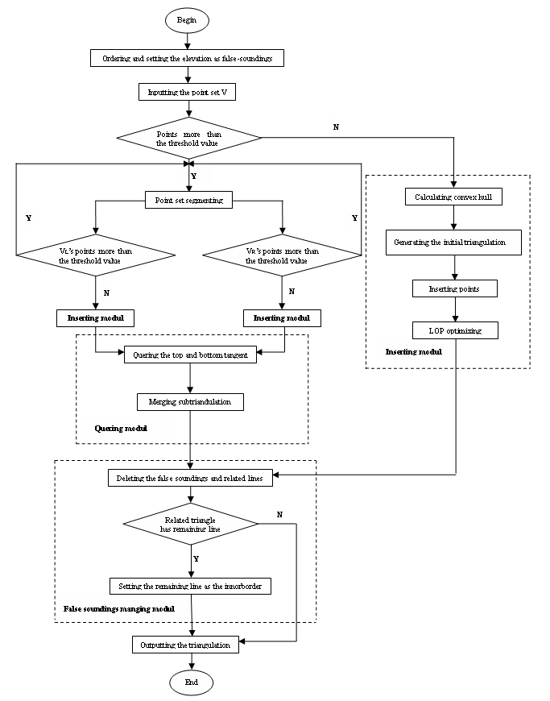

Fig. 3. Flow chart of soundings triangulation generation.
The dynamic maintenance of the sounding triangulation is different from the others. The positions of nodes of most triangles are changeless, while the depths they represent change. When the water lever changes, the coastline points will change, so what we need to do is to find the new coastline points, in this paper, we use an algorithm to integrate the elevation data and the soundings data. As we all know that, the elevation data is based on the altitude datum while the soundings data is based on the depth datum, for the sake of integrating, we should firstly ascertain a common datum. We transform the vertical datum of the ground data to the lowest normal low water, i.e. the depth datum, and then the elevation data has the same datum with the soundings. We treat the problem in this way because what we concern about is the navigation safety, the coastline points with 0m depth will not affect the safety of navigation. Then, we set the elevation of the points as the false-soundings, and no matter how the sea lever moves, the points with the 0m depth are the coastline points. Fig.4 shows the transformation between the altitude datum and the depth datum (EA means the altitude of the bare rock based on the altitude, ED means the altitude based on the depth datum, DAD means the distance between the altitude datum and the depth datum).
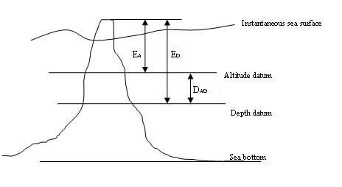

Fig. 4. Transformation between the altitude datum and the depth datum.
    - Navigable Area Generation Model
The navigable here is based on the soundings triangulation generated above, so when the triangulation changes, the navigable area will change. It means that, the navigable area generated here is just for a special period of time, it will change along with the time. So if the time is different, the navigable area will be different even for the same ship.
The generating of the navigable area needs four steps: firstly, get the safe depth based on the sea gauge of the ship, and generate the safe contour based on the safe depth; secondly, generate the initial navigable area within the confines of the safe contour; thirdly, make an area-intersect judge between the initial navigable area and the prohibited area and so on, then delete the intersected part from the initial navigable area; lastly, make an order of the areas’ navigability.
One of the most important techniques of this model is the generating of the safe contour. Generally, the isoline-tracing algorithm is used to generate the isoline in the triangulation, however, in the sounding triangulation, the generating of the safe contour is very important to the navigation safety of the ship, i.e. the contour must not extend towards the shallower side, which would be dangerous for ship navigation. In this paper, we apply the algorithm called the following node should thread the side having a shallower depth, which is developed by L. H. Zhang. This algorithm not only keeps the exclusive character of the contour, but also follows the request of the navigation safety.
After the safe contour has been generated, we find that, there are tow kind of contours: the first kind is closed, as to this kind of contour, what we need to do is to generate the area with the contour as the border; the other kind is not so lucky, normally, it will extend to the border of the chart. So as to this kind of contour, we treat it just as the line element, i.e. the border of the shallow, and it will not be used to generate the navigable area.
In the last step, we have to make an order of the area’s navigability, for this sake, we set an equation as follows:
In this equation, S means the navigability of the area; 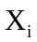means the factor which will affect the navigability of the area, such as the connectivity of the area, the sea gauge of the ship, the ship width, the area overlay and so on; 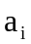means the significance of the related parameter. This step helps us to get the navigability of the navigable areas, also helps the voyager to design the route. Fig. 5 shows the flow of navigable area generation.
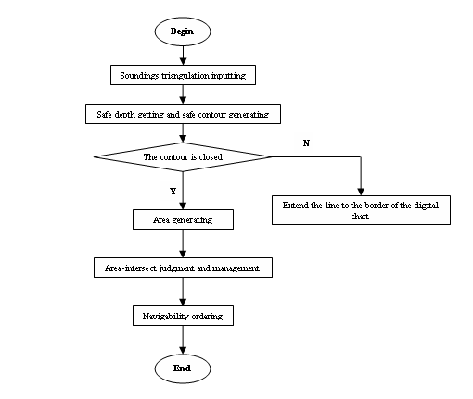

Fig. 5. Flow chart of navigable area generation.
- Conclusions
The result of this paper shows that, the spatial data includes a lot of information, some of them are well-marked and the others are connotative. By digging the connotative information, some new functions could be developed. Meanwhile, with the development of navigation technique, we need more and more connotative information of ocean spatial data. This paper is a good example of it. Furthermore, the result of this paper can be used in ECDIS as an intelligent function for navigation, especially analyzing and showing the dynamic navigable area to ensure safe for both war ships and civilian ships in emergency.

References
- G. B. Li and F. D. Wu, “Rudimentary Research on Actuality and Study Direction of TGIS,” China Science and Technology Information Feb.2006.
- H. P. Lin, “The Development of the Conception of the U.S. Territorial Water and Navigable Area,” World Shipping. 1999(4).
- W. Cao, X. H. Hua, Y. M. Xu, “Temporal GIS and its Application,” Geospatial Information, 3(6), 31-35 (2005).
- X. D. Wang, W. H. Cui, “Implementation of Digital Earth’s Spatio-Temporal Dimensions,” Progress in Geography, 18(2), 147-149 (1999).
- Y. C. Liu, Space Structure and Data Processing in Marine Sounding, Surveying and Mapping Press, Peking, 2003.
- X. L. Zhai and X. T. Wang, “The Function Analysis about the Marine Assist System,” Applications in Electronic Technique, 1998.
- R. C. Peng and J. Y. Wang, “A Research on Creating Buffer on the Earth Ellipsoid,” ACTA GEODAETICA et CARTOGRAPHICA SINICA, 31(3), 270-273 (2002).
- R. C. Peng, J.Xu and W. Z. Shen, “The Solutions to Some Key Problems of Accurately Delimitating Sea Area Boundary on the Ellipsoid,” Journal of Institute of Surveying and Mapping, 18(3), 210-212 (2001).
- S. Q. Zhang, “The key arithmetic to protract the isolines of the area based on Delaunay triangulation,” Computer & Network, 25(1), 39-41 (2005).
- X. B. Wu, S. X. Wang and C. S. Xiao, “A new study of Delaunay triangulation creating,” ACTA GEODAETICA et CARTOGRAPHICA SINICA, 28(1), 28-35, (1999).
- L. H. Zhang, “A Study on Drawing Depth Contours Using Grids Based on Irregular Area, Arbitrary Direction and Different Scale in Bathymetric Survey for Port Engineering,” Port & Waterway Engineering, 4(375), 9-13 (2005).
- S. L. Bao, G. A. Zhang and S. L. Chen, “Approach to isobath2change2model of tidal coast,” ACTA OCEANOLO GICA SINICA, 27(4), 76-81 (2005).
- R．C. Tan, Q. Y. Du, P. F. Yang and S. S. Zhang, “Optimized Triangulation Arithmetic in Modeling Terrain,” Geomatics and Information Science of Wuhan University, 31(5), 436-438 (2006).
- L. H. Zhang, Q. Zhu and Y. Chen, “A study for ambiguity in tracing depth contour on regular grid,” Science of Surveying and Mapping, 30(4), 20-21, (2005).
- X. Y. Wu and D. R. Zhang, “Improved algorithm for building Delaunay triangulation,” Journal of Zhejiang University(Science Edition), 31(3), 343-348(2004).
- Thomas Porathe, Gary Svensson, “An Historic Overview Of Mediated Communication At Sea,” International Visual Literacy Association’s conference, 2003.
- Thomas Porathe, “Visualizing the Decision Space of a Ship’s Maneuverability in a Real-Time 3-D Nautical Chart,” International Visual Literacy Association’s conference, 2004.
- Kurt A. Nelson, Joseph J. Tamul, “Adding Oceanographic Marine Information Objects to the Electronic Chart Display and Information System,” http://nelsonn@navo.navy.mil.
- Christopher Gold, Michael Chau, Marcin Dzieszko, Rafel Goralski, “THE ‘MARINE GIS’ – DYNAMIC GIS IN ACTION,” http://Christophergold@Voronoi.com.
- Thomas Porathe, “3-D Nautical Charts and Safe Navigation,” International Conference on Information Visualization, 2004.

